Toronto Metropolitan University

Lab Report 2:

The Hall Effect

Cheng, Vincent 501173673
Shai, Mourad 501170415
PCS 224 Section 09/14
Professor X. Yuan
T.A Revin Toquero
17 October, 2023

Introduction
In 1879, Edwin Hall observed a magnetic field, with a magnetic force defined by F = qv x B, where a current carrying material was placed. Current flow is determined by charges; these charges will flow to one side of the material because of the existence of this magnetic field. This results in the creation of an electric field and an electric potential (E_{H} and ∆V_{H} respectively) that have the ability to be measured with a voltmeter.

The Hall effect is the investigation of electric and magnetic forces, and how a larger magnetic force will result in a charge buildup. When the charge buildup ceases, it indicates that the magnetic and electric forces are equal in magnitude, and the hall voltage is constant. This is known as it’s equilibrium state, |E_{H}| = |v_{d}||B|.

In a rectangular solid, the magnetic field is across the thickness, current is across the length, and the Hall Eclectic Field is across the width. Hence:
- |∆V_{H}| = |E_{H}|W = |v_{d}||B|W → where W is the width

The Hall effect gives the sign of the charge carrier, something that would not be able to be found otherwise. In addition, the Hall effect includes the density of n charge carriers and the mobility μ charge carriers.

Theory
Using the torsion balance (Figure 1), Charles Coulomb measured electric forces for charged objects. The torsion balance will have the objects repel or attract resulting in a rotation. This rotation gives the value of electric force using the rotation angle.

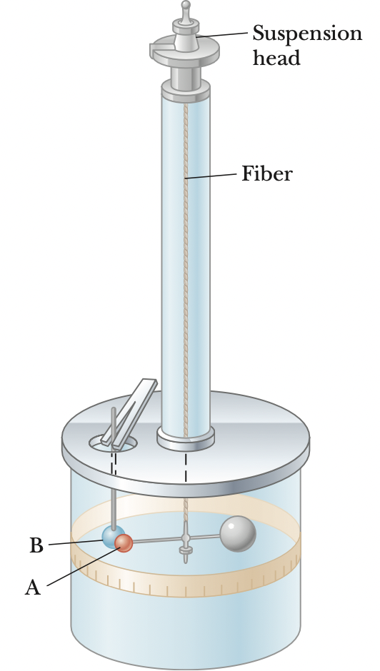

Figure 1. Image of the torsion balance (Serway and Jewett, Physics for Scientists and Engineers 10th ed. - Section 22.3 - 2018)

A point charge is the description of the behaviors of protons and electrons. Point charges do not have a size.

Coulomb’s Law describes the force of electrical attraction (F_{e}) between two charges:
- $F_{e} =\frac{ k_{e}|q_{1}||q_{2}|}{r^{2}}$ → k_{e} is Coulomb's constant (8.99 x 10⁹ Nm²/C²), q₁ is charge 1, q₂ is charge 2, and r is the radius. Where $k_{e} =\frac{1}{4πϵ_{0}}$→ ($ϵ_{0}$ = 8.85 x 10⁻¹²C)

A unit of free charge (e) has the value of 1.6 x 10⁻¹⁹C.

The potential difference (∆V) of an electric field can be defined as:
- ∆V = -Ed → where E is the electric field and d is the distance between two points in the vertical direction.

The right hand equation is negative since the second point is lower than the first. Electric potential (∆U_{E}) can also be measured if a charge (q) moves from the first to second point.

- ∆U_{E} = q∆V = -qEd

If the two points are separated both horizontally and vertically, equation (4) would instead look like:
- ∆U_{F} = q∆V = -qE•s → where s is the total distance between the two points

An equipotential surface is where points will have the same electric potential energy regardless of their position. Current (I) is defined as the charge (Q) flowing through one point per unit of time (∆t):
- I_{avg} = ∆Q/∆t

If the charge flowing through the point varies with time:
- I = dQ/dt

The units of an ampere (A) which relates to current is also defined as a Coulomb per second (C/s).
- 1 A = 1 C/s
In most cases, current is in the direction of the flow of electrons. However, for an accelerator with a positively charged beam, for example, the current would be in the direction of proton flow. A mobile charge carrier describes either a proton or electron creating a current.

The total charge within a cylindrical shape can be described as:
- ∆Q = (nA∆x)q → where ∆x is the length, A is the area, and n is the number of mobile charge carriers.
∆x can also be defined as drift velocity (v_{d}) multiplied by the time elapsed (∆t):
- ∆Q = nAv_{d}∆tq

If equation (9) has ∆t divided on both sides and using equation (6):
- I_{avg} = nAv_{d}q

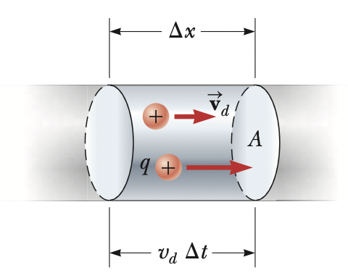
Figure 2. Current of a cylindrical shape (Serway and Jewett, Physics for Scientists and Engineers 10th ed. - Section 26.1 - 2018)

Any moving electric charge must also have a magnetic field (B). Magnetic field lines are the direction of the magnetic forces across the north and south poles.

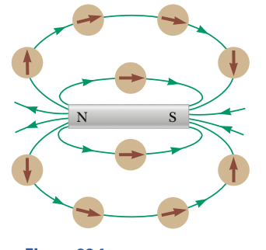
Figure 3. Magnetic field lines (Serway and Jewett, Physics for Scientists and Engineers 10th ed. - Section 28.1 - 2018)

The magnetic field can be calculated using the magnetic force (F_{B}) which are defined by the formulae:
- $F_{B} = qv x B$ → where v is the velocity of the mobile charge carrier

From this equation explains the B, v and F_{B} are all perpendicular to one another:

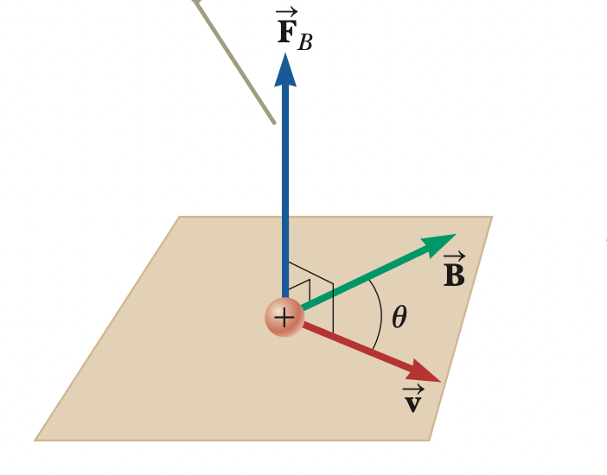
Figure 4. The relationship of F_{B}, v and B (Serway and Jewett, Physics for Scientists and Engineers 10th ed. - Section 28.1 - 2018)

As a result of this relationship, the right hand rule was created to easily find out the missing direction of the three if only two are obtained:

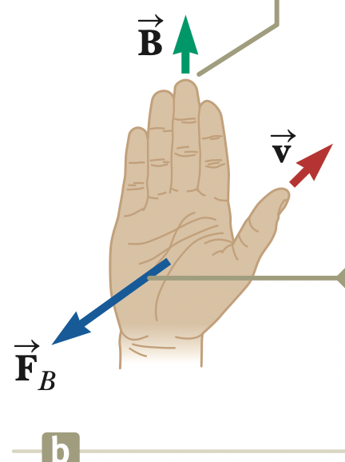
Figure 5. The right hand rule (Serway and Jewett, Physics for Scientists and Engineers 10th ed. - Section 28.1 - 2018)

If v and B are at an angle that is not 90 degrees, equation (11) would look like:
- $F_{b} = |q|vBsinθ$ → where $θ$ is the angle between v and B

Magnetic fields are in the units of teslas (T):
- 1 T = 1 $\frac{N}{C • m/s}$ → where N are newtons, m are meters, and s are seconds

Using equation (8):
- $1 T = \frac{N}{A • m}$

The Hall Effect is where a flat conductor has a current in the horizontal direction, and a magnetic field created in the y direction. This makes the mobile charge carriers move in the direction of the magnetic force, therefore moving to the top or bottom of the conductor. The charge value at the top or button is known as the Hall voltage (V_{H}).

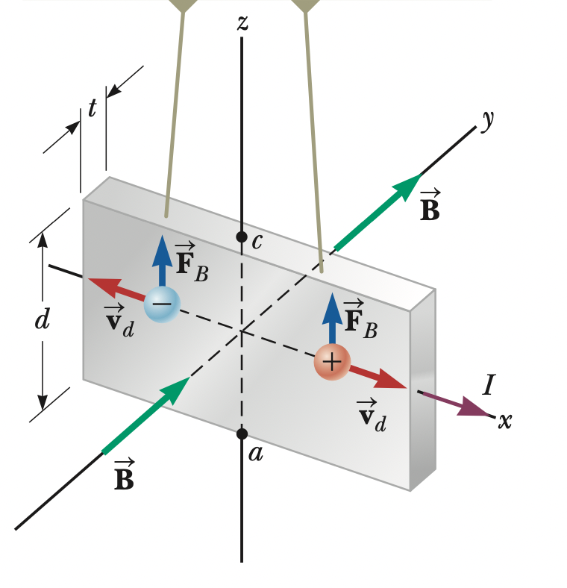
Figure 6. Diagram of the Hall effect (Serway and Jewett, Physics for Scientists and Engineers 10th ed. - Section 28.6 - 2018)

The equation for Hall voltage is:

- $∆V_{H} = E_{H}d = V$_{d}Bd → where d is the height and E_{H} is the magnitude of the electric field

In this case, the magnetic field:
- $B = \frac{nqt}{I}{∆V}_{H}$ → where t is the thickness of the conductor

Procedure
The lab was set up by placing one end of the red and black cables in the positive and negative terminals of the voltmeter respectively. The other end of the red cable was connected to the center right side of the germanium wafer board, and the black to the center left. The current supply had another two black and red cables that were connected to the germanium wafer board. The red (positive) was connected to the far left, and the black (negative) to the far right. The Tesla meter was zeroed by pressing the corresponding button. Multiple measurements were taken using the Tesla Meter, moving it slightly in the center of the magnet to find an average magnetic field. The voltmeter was turned on and the wafer was placed in the center of the magnet. The current source was turned on and set to 50 milliamps, making sure not to exceed 50 milliamps. For both this and the next part, uncertainties were recorded. The voltage on the voltmeter was recorded and the voltages were marked down for every decrease in 5 milliamps until the current source reached zero. The current supply and voltmeter were turned off. The wafer board was removed from the magnetic field and the positive and negative cables of the voltmeter on the wafer board were moved to the same places as the current source’s wires on the board. This made it so that the red wires were together on the far right and the black on the far left. The board was put back into the magnet and the current source and voltmeter were turned back on. The voltage values were recorded for every 5 milliamps beginning at 50 milliamps. The wafer board was removed, the voltmeter and current supply were turned off, and all of the red and black wires were taken out.
All recorded voltages and current values were compiled into a table for easy analysis. The average magnetic field was calculated from the multiple readings taken with the Tesla meter. Graphs were plotted or Current Vs Hall Voltage and Hall Voltage vs. Voltage Drop. Uncertainties were used to calculate the error bars for both values on the graph.
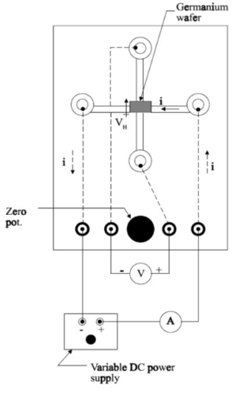
Figure 7. Germanium wafer board (Lab 2 - Hall Effect - page 4)

Apparatus
- Red and black cables
- Current supply
- Tesla Meter
- Multimeter
- Germanium wafer
- Magnet

Results and Data
Note: Wafer Board had no colour

Current $[I]$ (mA) $±0.05 mA$ | Hall voltage $[V_{H}]$ (V) $±0.005 V$ | Voltage Drop $[V_{d}]$ (V) $±0.005 V$
50 | 0.15 | 5.30
45 | 0.13 | 4.69
40 | 0.11 | 4.13
35 | 0.10 | 3.58
30 | 0.08 | 3.05
25 | 0.06 | 2.52
20 | 0.05 | 2.01
15 | 0.04 | 1.50
10 | 0.02 | 0.99
5 | 0.01 | 0.50
0 | 0.00 | 0.13
Table 1: Hall Voltage and Voltage Drop based on Current

Magnetic Field $[B]$ (T)
0.177
0.188
0.190
0.197
0.200
0.198
Table 2: Magnetic Field
*Based on these values the average value of Magnetic Field with uncertainty is $(0.192±0.023) T [down]$

Analysis and Calculations
Based on Figure 1, current $[I]$ travels to the left while magnetic field $[B]$ travels into the page, as evidenced by the positive readings. This means that charge carriers will be pushed to the lower edge of the germanium wafer where the positive terminal of the voltmeter is connected. The positive Hall Voltage $[V_{H}]$ values indicate that the majority charge carriers of the germanium wafer are positive. So, it is p-type.
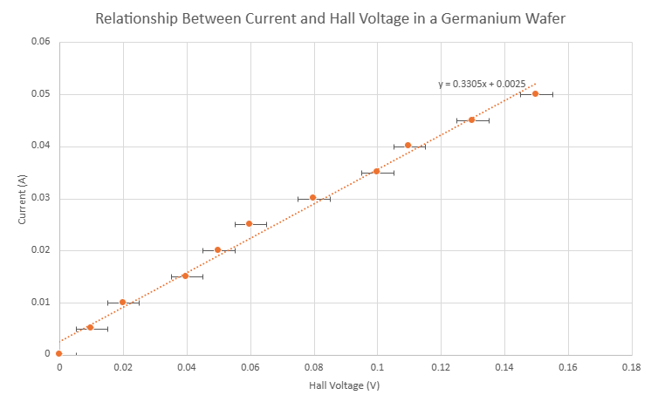
*Vertical error bars are too small to be visible
Figure 8: Graph of Current vs. Hall Voltage

Determining Carrier Concentration n
$Slope =\frac{i}{\left|V_{H}\right|}$

$i=neAV_{d}$ (1)
$\left|V_{H}\right|=W\left|v_{d}\right|\left|B\right| ⇒\left|v_{d}\right|=\frac{\left|V_{H}\right|}{W\left|B\right|}$ (2)

Substitute:
$i=\frac{neWt\left|V_{H}\right|}{W\left|B\right|}$ $⇒i=\frac{net\left|V_{H}\right|}{\left|B\right|}$

Rearrange:
$n=\frac{i\left|B\right|}{et\left|V_{H}\right|}$
$n=slope×\frac{\left|B\right|}{et}$
$n=(0.3305±0.0111)amp/V×\frac{(0.192T±0.023T)}{(1.602×10^{-19}C)(0.001 m)}$
$n=(3.961×10^{20}±6.07x10^{20})m^{-3}$

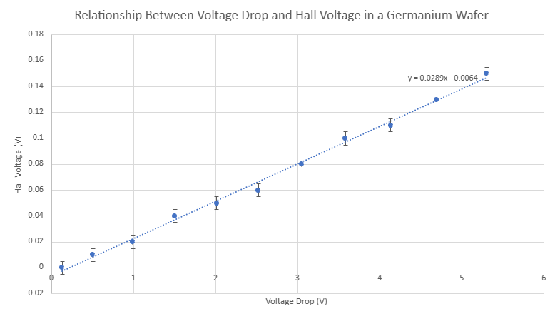
Figure 9: Graph of Hall Voltage vs. Voltage Drop

Determining Carrier Mobility $μ$
Slope: $\frac{\left|V_{H}\right|}{\left|V_{L}\right|}$
$\left|V_{H}\right|=\frac{W\left|B\right|μ\left|V_{L}\right|}{L}$ (1)

Rearrange:
$μ=slope×\frac{L}{W\left|B\right|}$
$μ=0.0289±0.01×\frac{0.01 m}{(0.005m)(0.192T±0.023T)}=0.301±0.14\frac{m^{2}}{V⋅s}=3010±1400\frac{{cm}^{2}}{V⋅s}$

Determining Percent Error of Carrier Mobility $μ$
$Percent error = \frac{|3010 −1900|}{1900 }× 100\%$
$Percent error = 58.42\%$
The percent error of the calculated carrier mobility compared to the accepted value is relatively large. However, the accepted value is within the uncertainty range of the calculated value.

Discussion/Conclusion
Determining Conductivity $σ$
$σ=enμ$
$σ=(1.602×10^{-19}c) (3.961×10^{20}m^{-3}±6.07x10^{20}m^{-3}) (0.301\frac{m^{2}}{V⋅s}±0.14\frac{m^{2}}{V⋅s})$
$σ=19.1(Ω⋅m^{-1})$

A positive Hall voltage does not always mean that the conductor is a p-type. If the positive and negative terminals of the voltmeter are reversed, then the voltage will read out the negative of the original value. This would mean that a positive voltage would result in a n-type.

The calculated conductivity of our germanium wafer is greater than the conductivity of intrinsic germanium. This is expected because our wafer is p-type, meaning that it is doped. As a result there will be more charge carriers than in the intrinsic semiconductor, therefore increasing conductivity which is the measure of how easily electricity can travel through a material.
Based on the given equation:
$\left|V_{H}\right|=W|V_{d}||B|$
It is evident that Hall Voltage is directly proportional to the magnetic field. So, if the magnitude of the magnetic field increases, so will the magnitude of the Hall Voltage.
The mobility is an intrinsic property of the material, which means it's independent of the applied magnetic field. So, when the magnetic field is increased (and all other parameters are kept constant), the mobility will remain the same and only Hall Voltage will increase.

References

Dr. Yuan Xu. 2023 Fall. Hall Effect PCS224 [lab manual]. Toronto (ON): Toronto Metropolitan University

Serway, R. A., & Jewett, J. W. (2018). Physics for scientists and engineers (10th ed.). Cengage Learning.
Toronto Metropolitan University. (n.d.). Physics Lab Guide [PDF]. D2L. https://courses.torontomu.ca/d2l/le/content/795518/viewContent/5278918/View

